1. Explain the difference between frontend, backend, and full-stack development with
suitable real-world examples.
ANS.
Frontend Development: Builds the user interface of a website using HTML, CSS, and JavaScript.
Example: Product pages on Amazon.
Backend Development: Handles server, database, and logic of the website using Node.js, Python, or Java.
Example: Logging in to Netflix and fetching account data.
Full-Stack Development: Works on both frontend and backend, creating a complete web application.
Example: A food delivery app with UI and order management.

2. Create a simple diagram showing how the client-server model works in web architecture.
ANS.
+-------------------+ Request (e.g., HTTP GET) +-------------------+
| Client | <-------------------------------------> | Server |
| (Web Browser, App)| | (Web Server, DB) |
+-------------------+ Response (e.g., HTML, Data) +-------------------+
^ ^
| |
| |
| |
| |
+-------------------+ +-------------------+
| User Input | | Data Storage |
| (URL, Clicks) | | (Database) |
+-------------------+ +-------------------+

3. Describe how a browser requests and displays a web page from a web server.
ANS.
When a user enters a web address (URL) in the browser, the following steps occur:
- DNS Lookup:
The browser contacts the Domain Name System (DNS) to find the IP address of the web server hosting the website.
- Request Sent:
The browser sends an HTTP or HTTPS request to the web server for the required web page.
- Server Processing:
The web server receives the request, processes it (with help from backend logic if needed), and retrieves the requested files such as HTML, CSS, JavaScript, or images.
- Response Sent:
The server sends these files back to the browser in the form of an HTTP response.
- Rendering the Page:
The browser interprets the HTML, applies the CSS for styling, runs JavaScript for interactivity, and finally displays the complete web page to the user.

4. Identify and list the tools required to set up a web development environment. Explain the
purpose of each.
ANS.
A complete web development setup includes a code editor, browser, server, database, version control, and debugging tools — all working together to build and test web applications.

5. Explain what a web server is and give examples of commonly used servers.
ANS.
A web server is a system that stores and delivers web pages to users over the internet using the HTTP/HTTPS protocol. When a user requests a website, the server processes the request and sends back the required files like HTML, CSS, or images for the browser to display.
Examples: Apache, Nginx, Microsoft IIS, Node.js.

6. Define the roles of a frontend developer, backend developer, and database administrator
in a project.
ANS.
Frontend Developer: Designs and builds the website’s user interface using HTML, CSS, and JavaScript. Backend Developer: Handles the server-side logic and ensures communication between the frontend and database. Database Administrator (DBA): Manages and maintains the database, ensuring data is stored, secure, and retrievable.

7. Install VS Code and configure it for HTML, CSS, and JavaScript development. Take a
screenshot of the setup.
ANS.
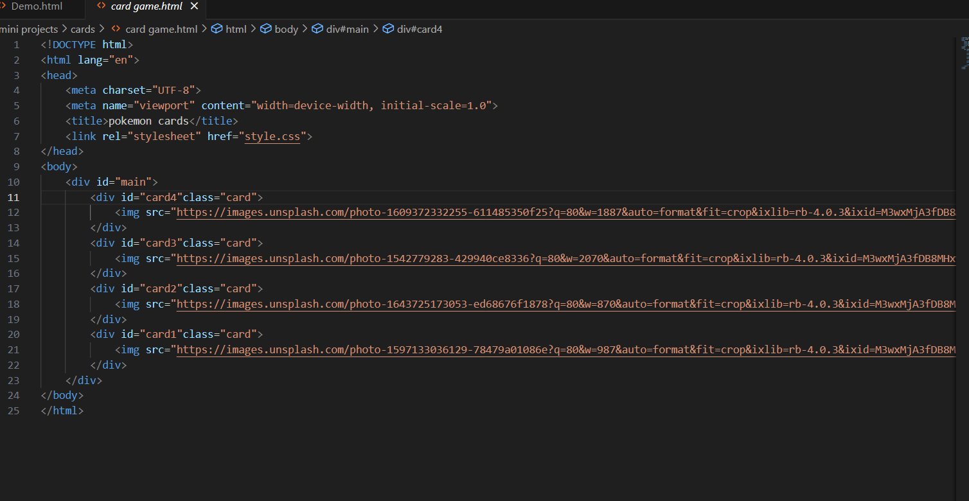
8. Explain the difference between static and dynamic websites. Provide an example of
each.
ANS.
Static Website:
Shows fixed content that does not change unless manually updated. Example: A personal portfolio website.
Dynamic Website:
Shows changing content based on user interaction or database.
Example: Facebook or Amazon.

9. Research and list five web browsers. Explain how rendering engines differ between
them.
ANS.
Five Web Browsers: Chrome, Firefox, Edge, Safari, Opera.
Rendering Engines:
Chrome & Edge: Blink
Firefox: Gecko
Safari: WebKit
Opera: Blink

10. Draw a labeled diagram showing the basic web architecture flow — client, server,
database, and APIs.
ANS.
+-------------------+ HTTP/S Request +---------------------+ API Calls +-------------------+
| Client | ----------------------> | Server | --------------------> | Database |
| (Web Browser/App) | <---------------------- | (Web Server/Backend)| <-------------------- | (Data Storage) |
+-------------------+ HTTP/S Response +---------------------+ Data Retrieval/ +-------------------+
Storage

^
|
API Layer
|
v

+-----------------------+
| External APIs/Services |
| (e.g., Payment Gateway, |
| Authentication) |
+-----------------------+

